Ukulele – D, Bm, G, Bm,
D

Bm G

D Bm
I got this feeling inside my bones
G Bm
It goes electric, wavey when I turn it on
D Bm
All through my city, all through my home
G Bm
We're flying up, no ceiling, when we in our zone

D
I got that sunshine in my pocket
Bm
Got that good soul in my feet
G Bm
I feel that hot blood in my body when it drops
D Bm
I can't take my eyes up off it, moving so phenomenally
G Bm
Room on lock, the way we rock it, so don't stop

D Bm
Nothing I can see but you when you dance, dance, dance, dance
G
feeling good, good, creeping up on you
Bm
dance, dance, dance, come on
D
All those things I shouldn't do
Bm
But you dance, dance, dance, dance
G Bm
And ain't nobody leaving soon, so keep dancing
D
I can't stop the feeling
Bm
So just dance, dance, dance
G
I can't stop the feeling
Bm
So just dance, dance, dance, come on

D-dur D F# A

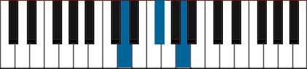
D F# A

B-moll B D F#

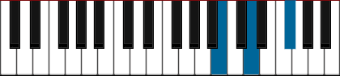
B D F#
G-dur G B D

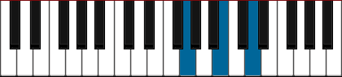
G B D

